Why? What? How?

Monolithic architecture

What is Monolithic?

Application packed in single large block, Large, indivisible, slow to change, inflexible and immovable.

What is Monolithic architecture?

Self Contained – packaged & deployed as single unit. All components of application are packed and deployed together.

All the application layers are build together and tightly coupled.

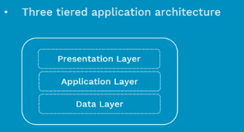

Advantage:

* Single unit for develop n deployment.
* IDE support.

Disadvantages:

* Often very large
* Technology dependency on the initial decision.
* Implemented using single development stack.
* Frequent deployment are not practical.
* Need to scale entire application stack.
* Big problem is dynamic scalability and Flexibility.

MicroService

Creating smaller and multiple component services which are built to handled a very specific concerns/business requirement.

Internally talk with each other with well build API using Https or messaging Q.

Characteristics:

1. Autonomous: independent
2. Specialized: for specific business requirement.

Advantages:

* Flexible scaling
* Easy Deployment
* Technological Freedom
* Reusable code
* Resilience: part of service is down

Disadvantages:

* Spawning: grow the microservice
* Maintenance
* Duplicate Code
* Network Performance is like latency

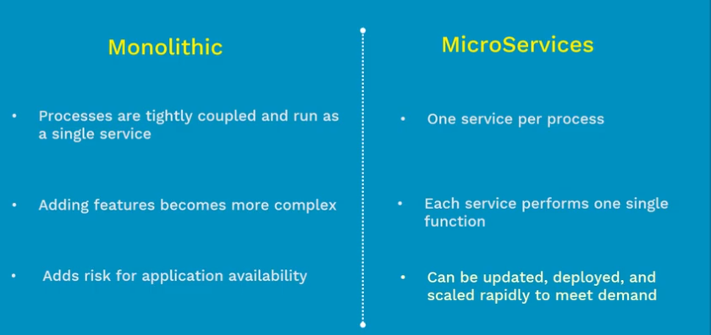

Where do you run this Microservice?

1. Physical Servers
2. Virtual Machines
3. Containers

Containers:

**Why Containers?**

Applications is build using lot of components like java, python , .net, mysql, Nginx etc.

Containers answers for portability and compatibility.

Container will package all your application code and its dependences, and ship it into public/private repository, and download and run it any where. Yes application will behave wherever u run it.

Container contains only required libraries and app services.

**Container Architecture**:

Container virtualize at the OS level, where VM virtualize is at hardware level.

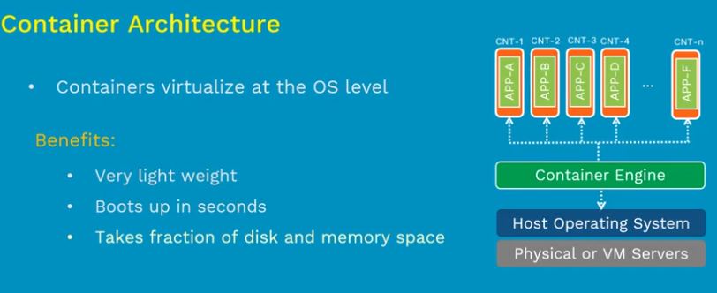

Advantages:

* Portability
* Resources efficiency
* Isolation: if one down there will not be harmed.
* Speed
* Scaling: Horizonal scaling

Container Engines:

1. Docker: is from Docker Inc
2. Rocket(rkt) : is from redhat

Physical vs VM vs Containers

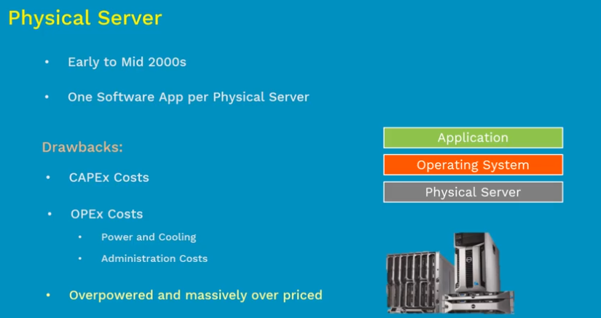

One to one mapping between app, os and underlaying hardware.

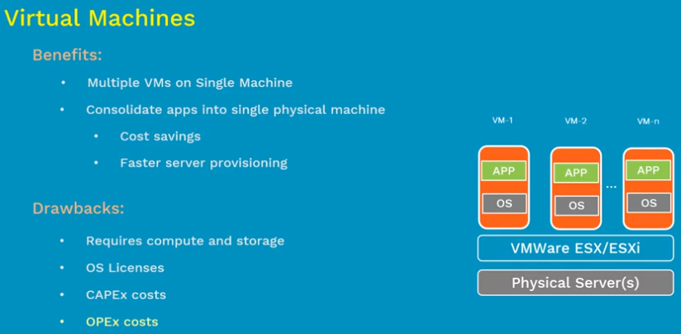

One to one mapping between physical server and hypervisor , map to one between VMs and hypervisor.

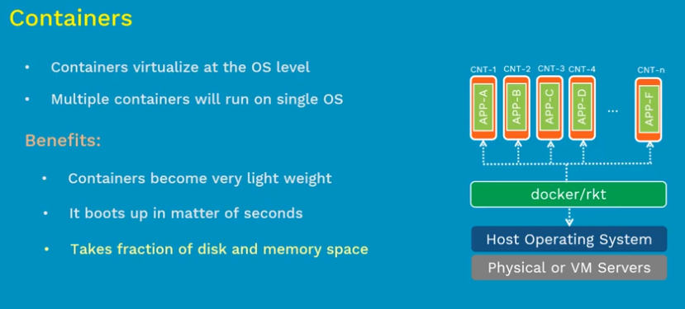

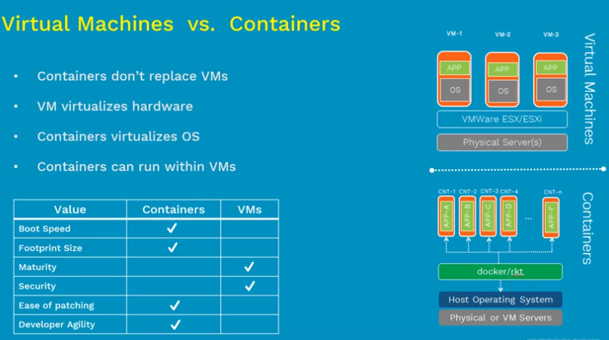

Dockers: Docker inc was dotCloud first, which produces product docker container engine, docker swam and docker hub. ( Dock Worker) written in GO language.

What docker does?

1. Build: Docker Image
2. Ship: Docker Hub/Docker Store
3. Run: Docker Container

Docker Hub:

is used to store the docker images remotely. Docker hub is like google drive, Docker images are like files and Repository(private or public) are like folder.

Docker Project:

Is open sources and free to edit. Docker Inc drivers the Docker project.

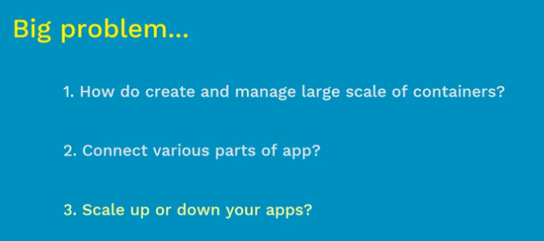

Like Google run 2 billion containers per week.

**Container Orchestration Engine**

Container Orchestration Engine automates deploying, scaling and managing containerized applications on a group of servers. Clustering & Scheduling are imp for features for COE

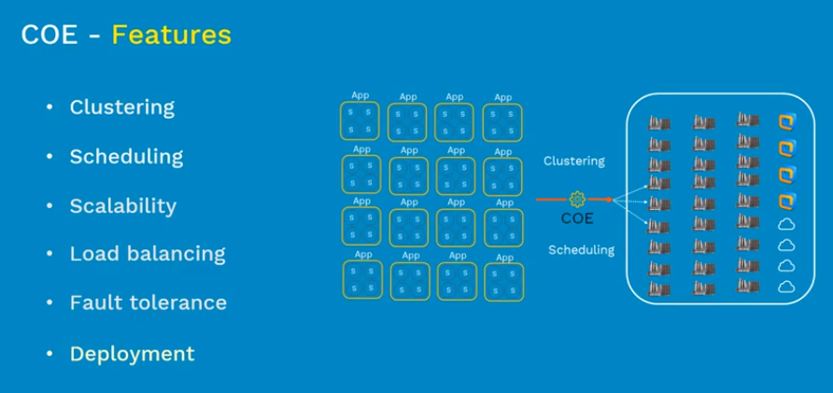

# TOP 3 Container Orchestration Engines

1. Marathon: from Apache Mesos
2. Docker Swarm: from Docker Inc
3. Kubernetes: from CNCF

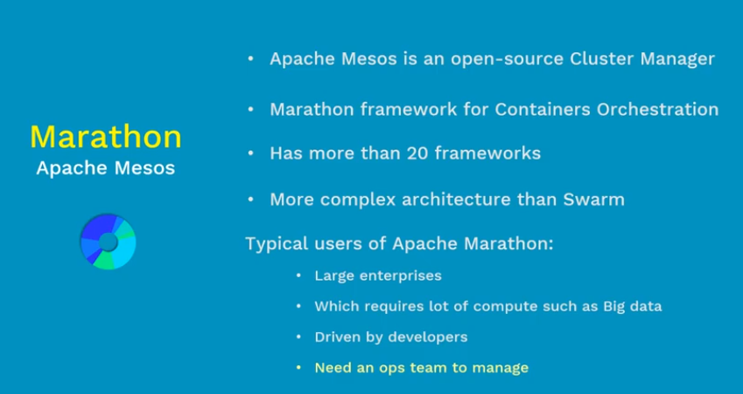

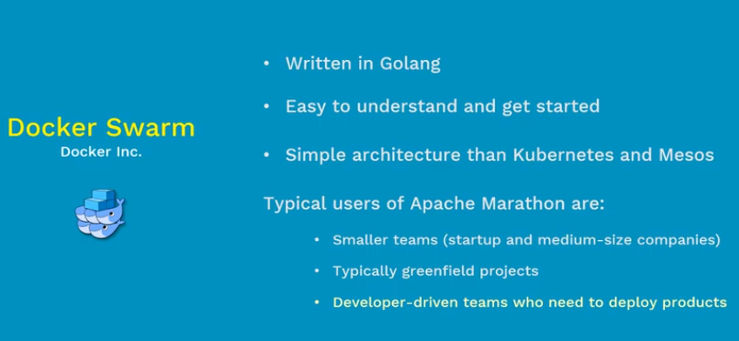

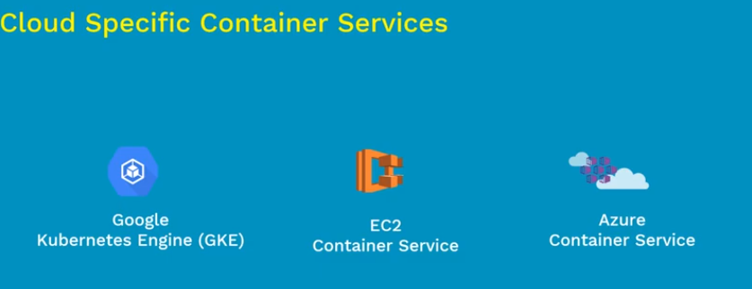

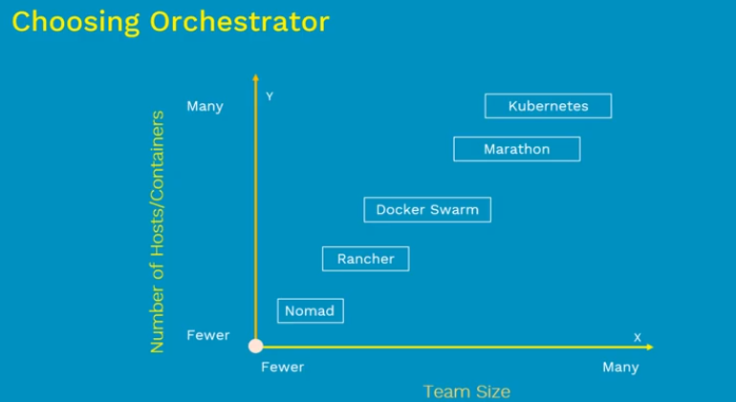

# What is Kubernetes?

Kubernetes is open sources COE, Manages containerized apps @ large scale.

With Features:

Cluster management, Scheduling, Service discovery monitoring, secrets management and more

Google -> CNCF(cloud native foundation).

Google uses Brog

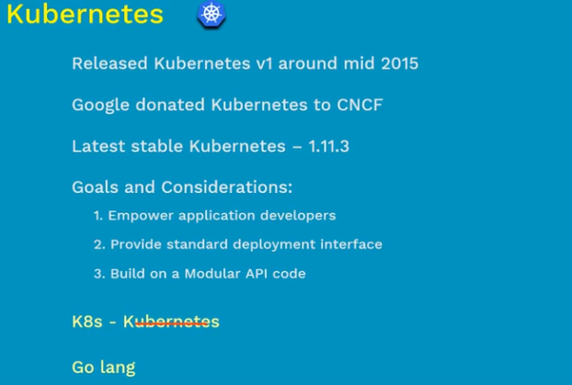

Why Kubernetes?

* Google Inc
* Maturity
* Features
* Easy Integration
* Community

# Kubernetes Architecture

(manger and worker model)

Basic Architectures:

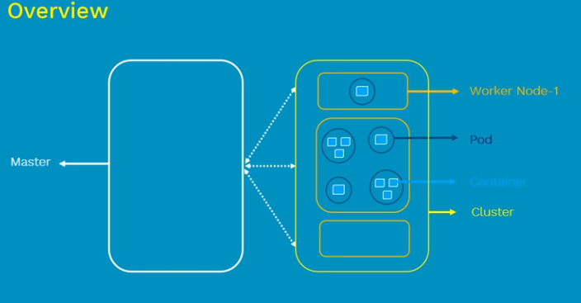

Workers Node / Minyans:

Pod: Basically scheduling unit in k8s, pod as VM in virtualization world, in K8s its pod. Pod contains one or more containers. There are cases where one or more dependent container run in same pod(where one container is helping another container). With help of pods we can deploy dependent containers together. Pod are rapper around containers.

Master: Master is responsible for managing whole cluster. It monitories health check of each on Nodes, It shows the member of clusters and configuration inside the master. When worker node fails the traffic is transferred to healthy node. Master is also responsible for scheduling, provisioning, controlling and exposing API to client.

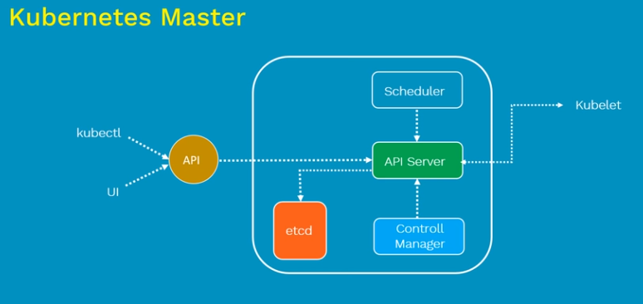

Kubernetes Master is responsible for managing overall cluster, It coordinates all the activities inside the cluster and communicates with worker nodes to keep K8s and our application running.

1. API Server: Act as gatekeep for entire application cluster, Which is responsible for create, delete, update or display any K8s object its as to go through this APIs, APIs server validates and configurated API object such as pods, services, replication control and deployments. Its responsible for exposing varies APIs for all the operation. Interaction with this APIs are done by **Kubectl(its Golang binary)** and **UI which interact with API server through command prompt)**
2. Scheduler: Is responsible for physically scheduling pods across multiple nodes, so depending on constrainer specified in configuration files. Ones artifact send to API server, Scheduler looks for appropriate nodes that meets this criteria and while schedule pod accordingly.
3. Control Manager: There are four controllers behind Control manager Node Controller, Replication, Endpoint and service accountant token controller. Is responsible for overall health checkup of cluster. Ensures nodes are up and running , correct number of pods as mentioned in spec file.
4. Etcd: Its key value light weight DB, Its central DB for K8s to store current cluster status at any point of time.is sost

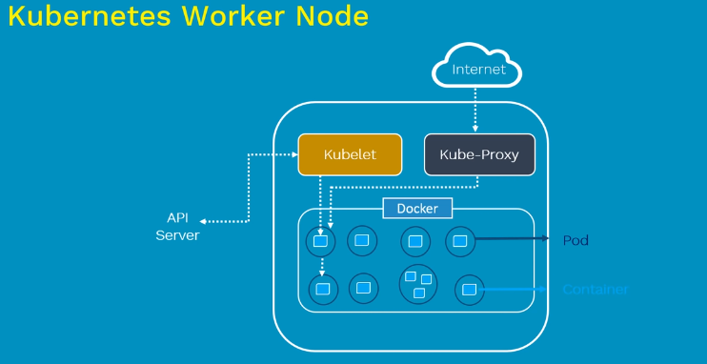

Worker Node can be any physical server or VM where container are deployed. Every node in cluster must run runtime env such as docker/rkt. Two components required to communicates with K8s Master. They are

1. Kubelet: Kubelet is primary node agent that runs on each node inside the cluster. Primary objective is it looks for pod spec submitted by API server from K8s mater and ensure that containers described in that pod are running and healthy. In case Kubelet notices any issues with pod running on worker nodes it tries to restart the pod on same node, Incase the issue is with Node then in that case master detect node failure and tries to recreate the pods on another healthy node, It all happens if pods are controlled by replica set/ Replication controller. If not pod dies and not recreated.
2. Kube-Proxy: Its responsible for maintaining entire network configurating. Escically maintain distributed network across all the nodes, all pods, all containers. Also exposes services to outside world. Its core networking components in K8s
3. Pods
4. Containers: Application libraries and there dependences

K8s supports 5000 nodes in single cluster.

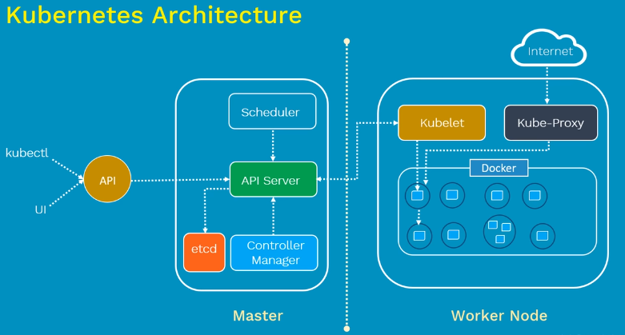

# Installation Methods of Kubernetes

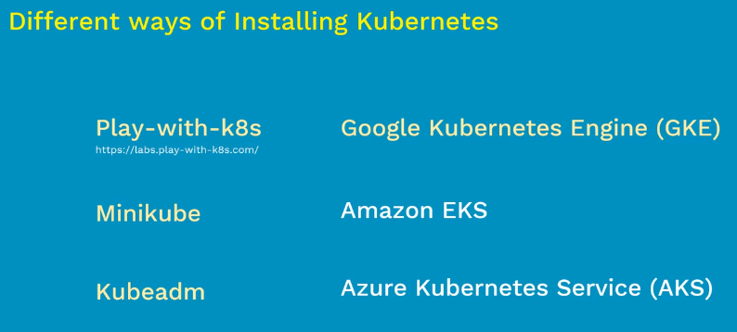

# Kubectl in Kubernetes

Its command line utility for running commands against Kubernetes clusters. Even we can create, modify, displaying, delete any K8s object in K8s.

Kubectl or kube control or kube command line tool.

Syntax:

Kubectl [command] [type] [Name] [flags]

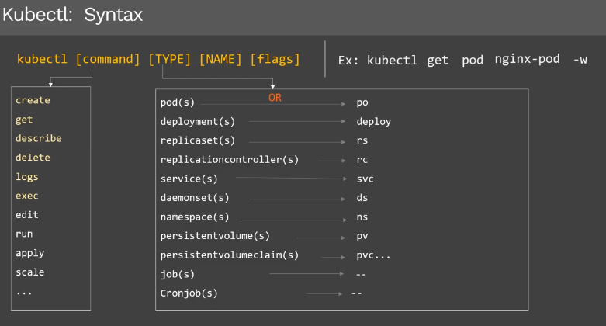

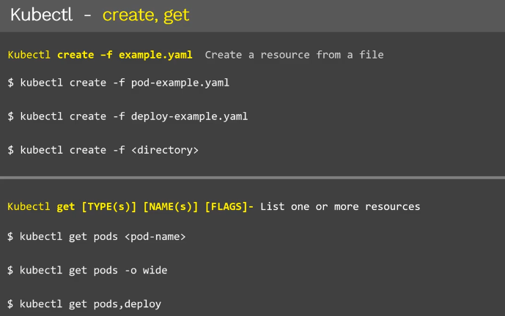

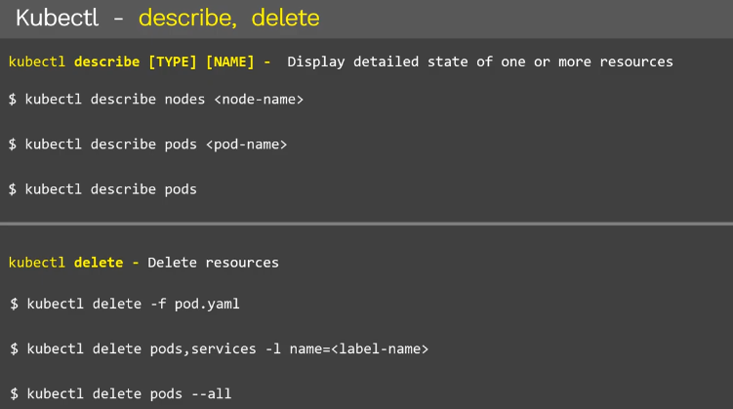

-it means interactive terminal. Exec – exact command

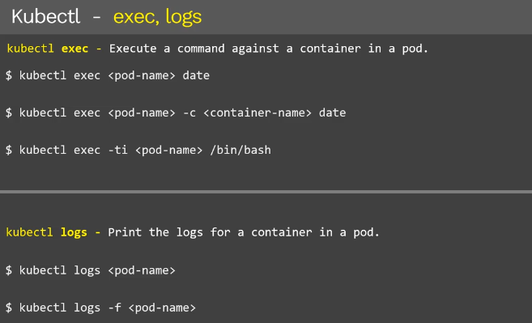

# Play-With-K8s (PWK) in Kubernetes

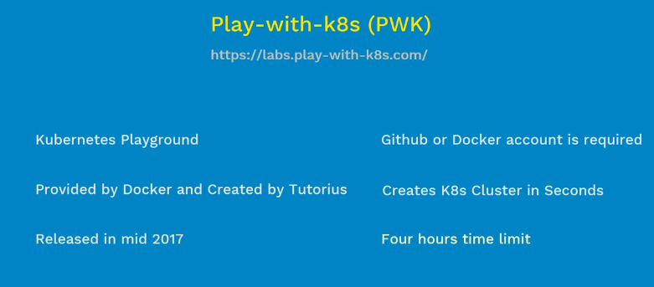

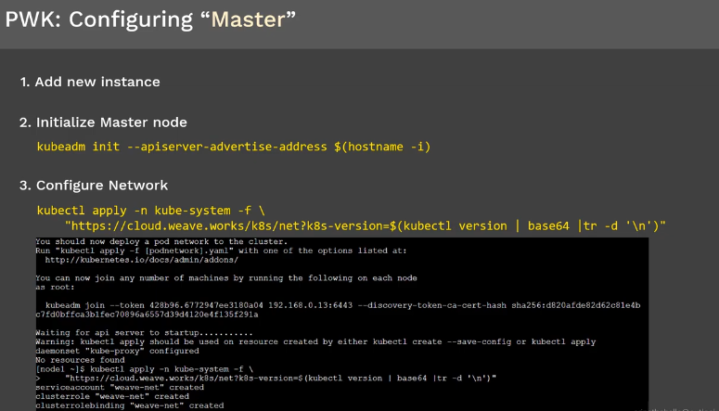

Network plugin is used to establish communication between all the pods and all nodes inside cluster, other plugin like flanal, calclico and weave.

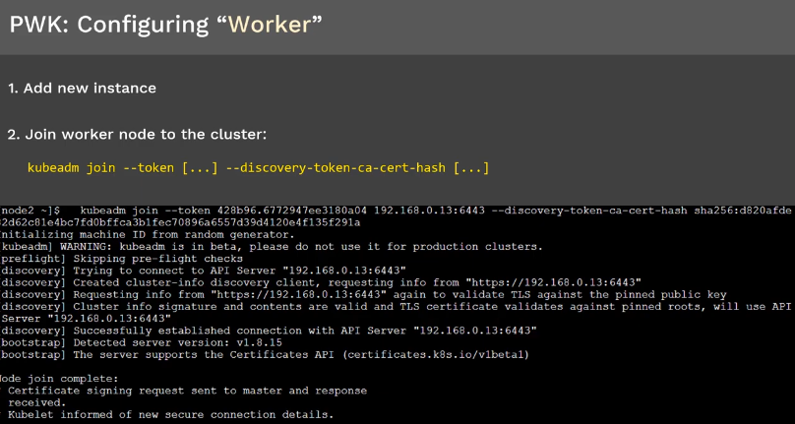

# Minikube in Kubernetes

Used to run K8s in local

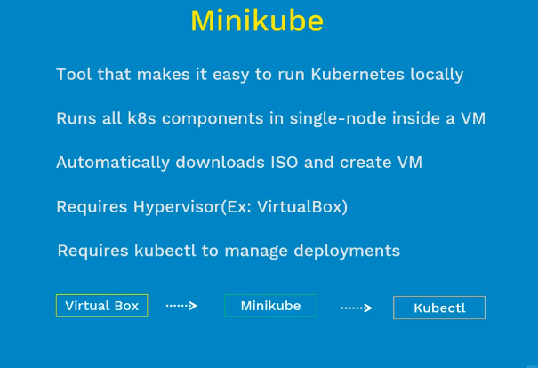

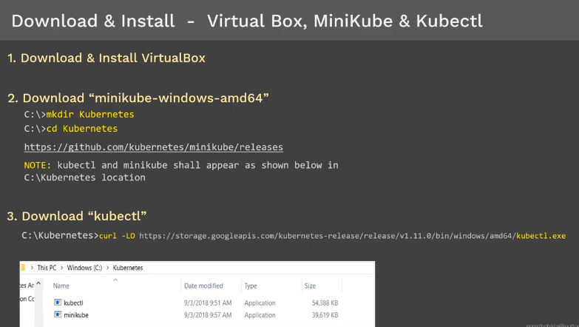

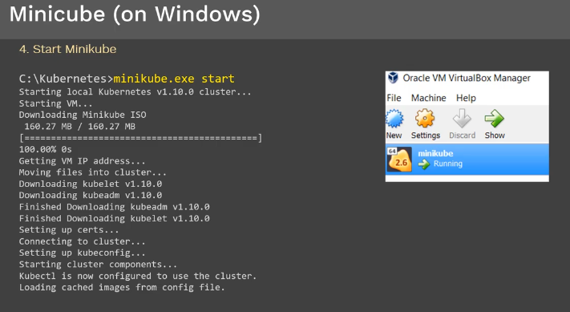

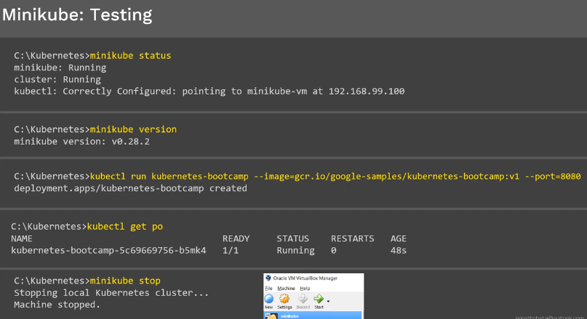

# Google Kubernetes Engine (GKE)

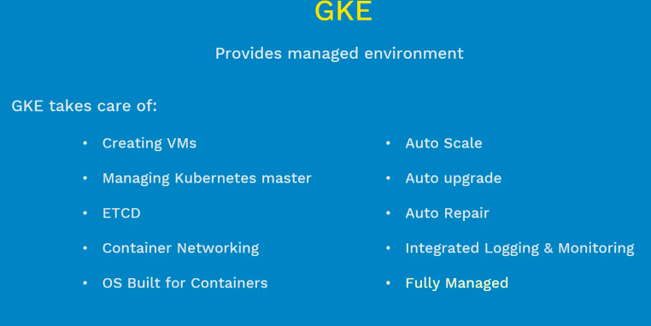

# Installing Kubernetes using Kubeadm

Kubeadm helps with installing and configuring Kubernetes cluster.

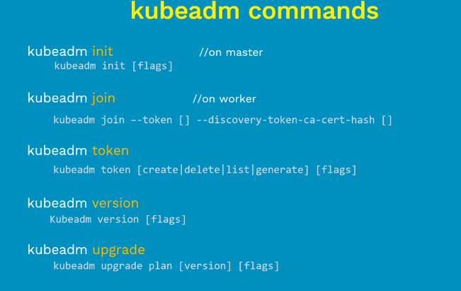

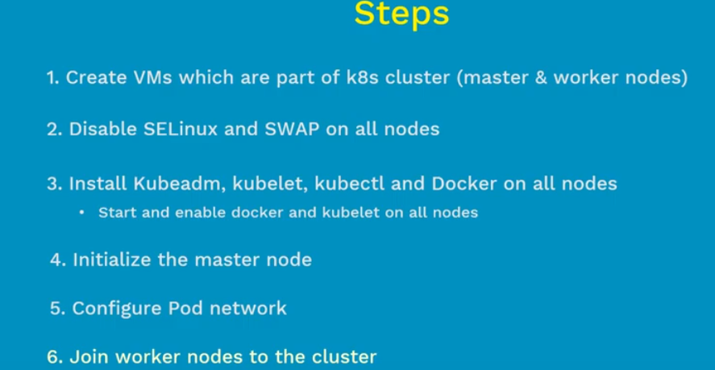

# Pods in Kubernetes

Pod is atomic unit of scheduling

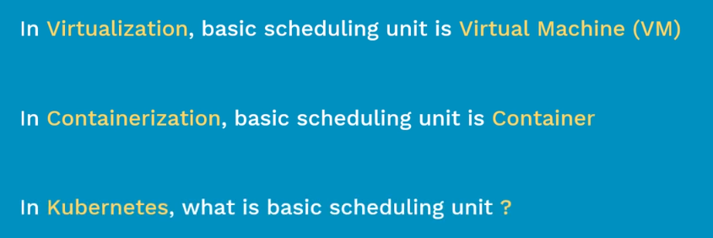

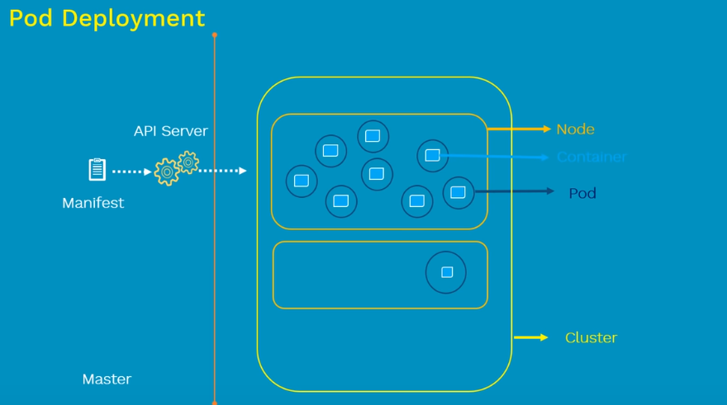

What case for the having multiple container per pod?

* Where helper container supporting for the main web app such as user entire data, file processing etc , it uses same host name and even same data store

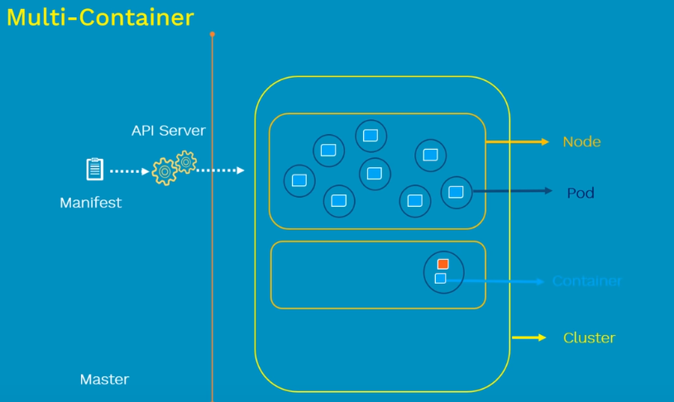

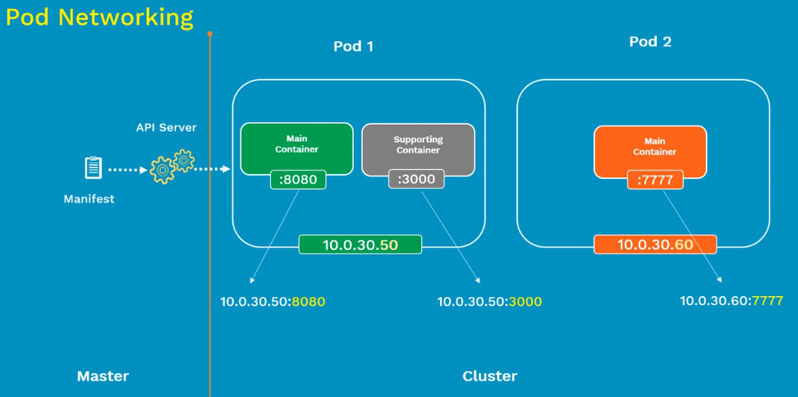

Inter pod communication: communication between two pods is doneusing pod network plugin (weave etc..)

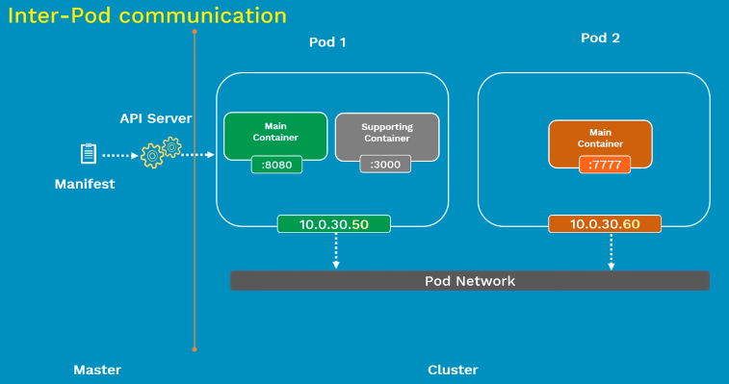

Intra pod communication:

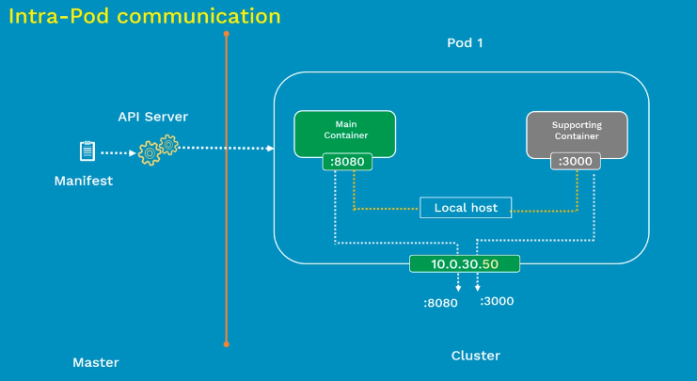

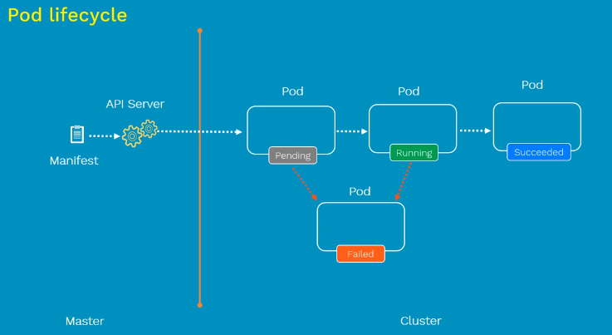

Configuration of Pod: below config it will create one pod containing nginx container in cluster.

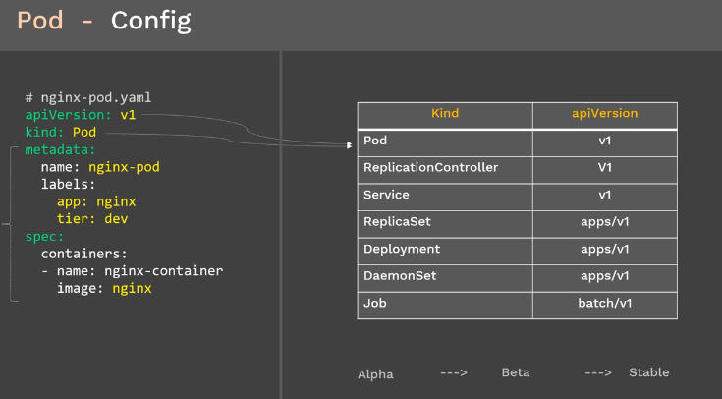

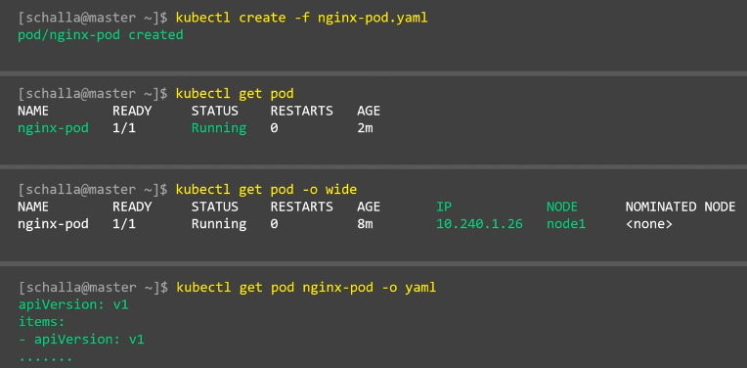

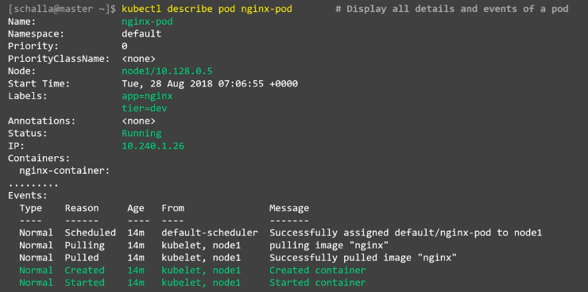

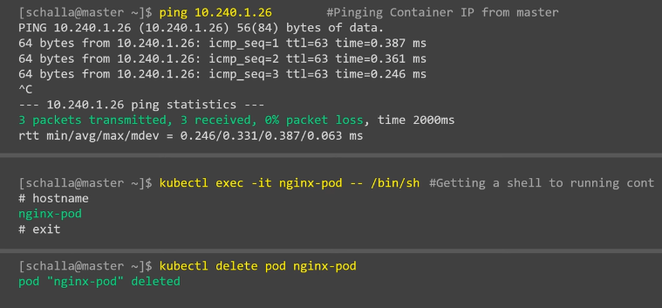

# Replication Controller in Kubernetes(rc)

How to make sure at least 3 pods is up and running?

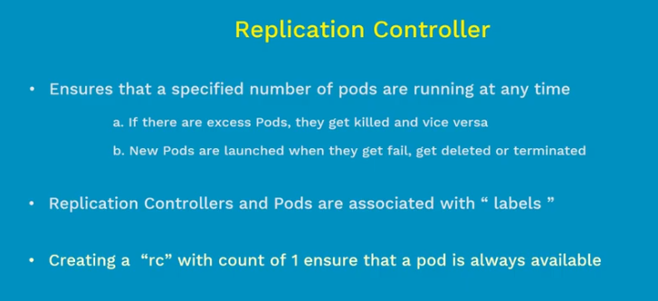

Advantages: replication controller as 2 in below.

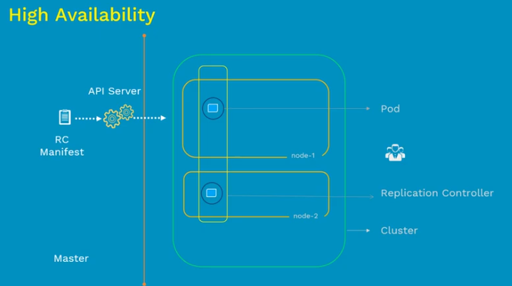

As the increase in user increase the pods using replication controller & it is load balanced.

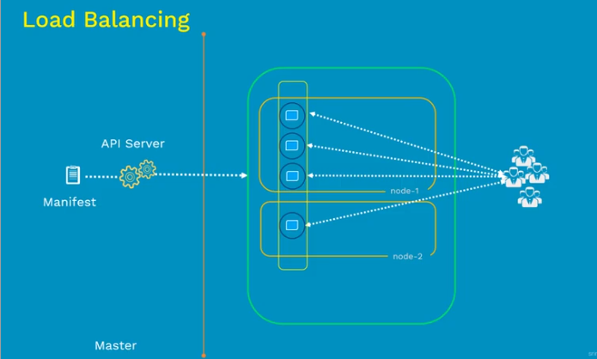

Replication controller is OLD and its replaced by Replica sets. One difference between is RC supports equality based selectors, where RS support set based selectors.

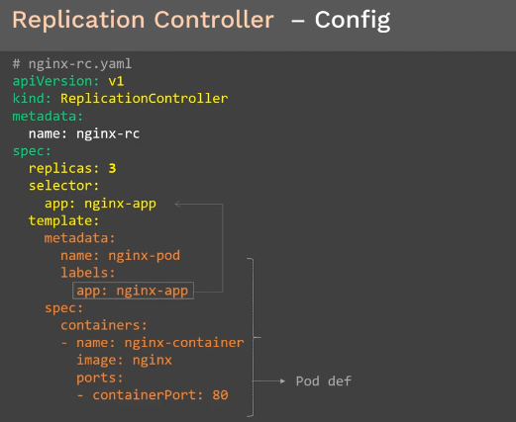

Creating replication, displaying pods and displaying only nginx-app using label.

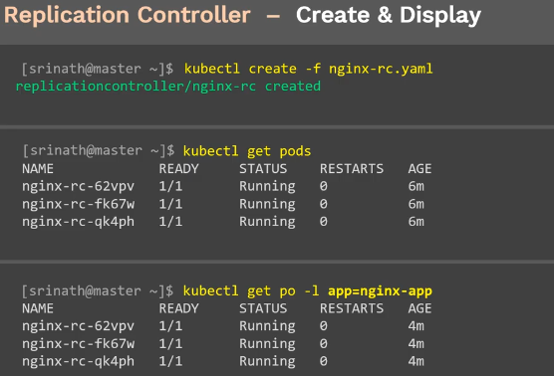

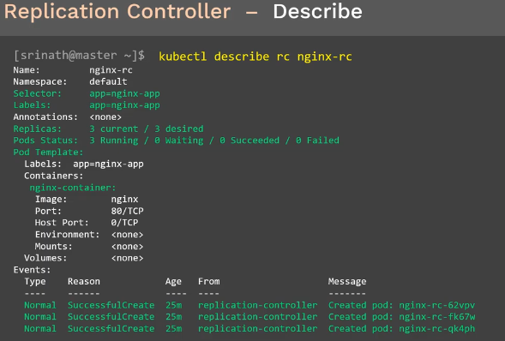

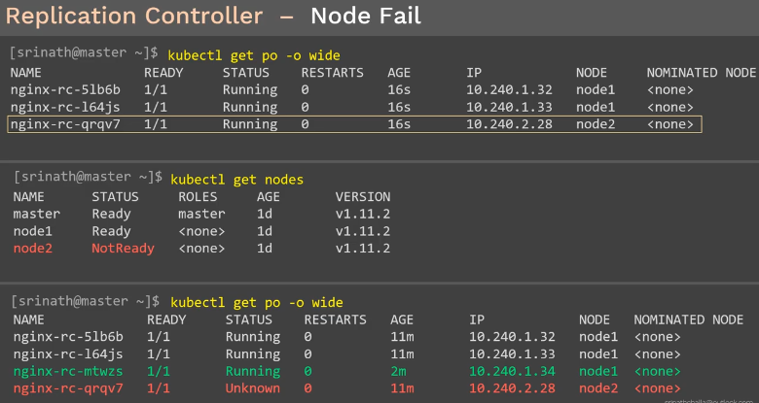

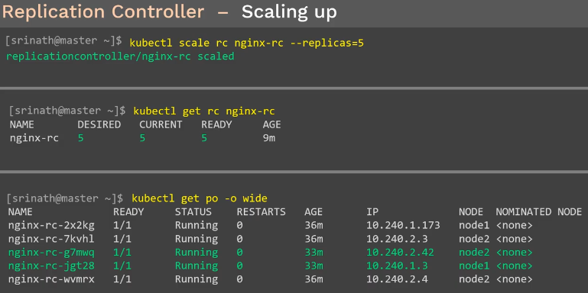

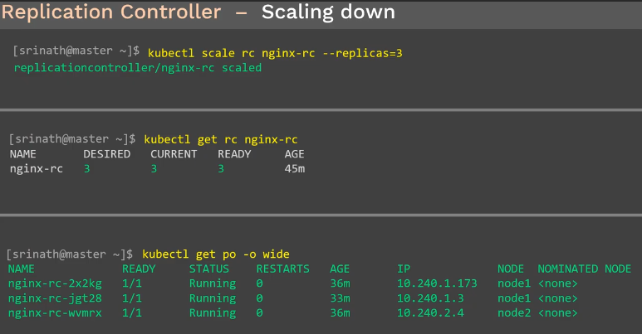

Deletes the RC and all the pods controlled by the RC.

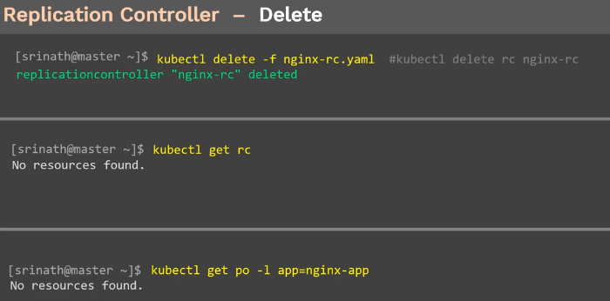

# ReplicaSet in Kubernetes(rs)

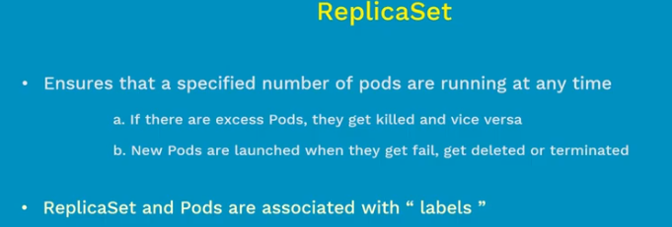

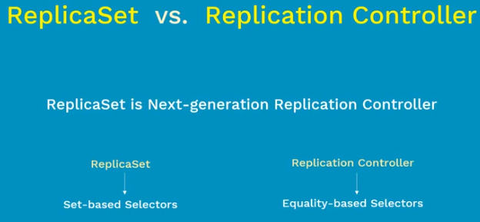

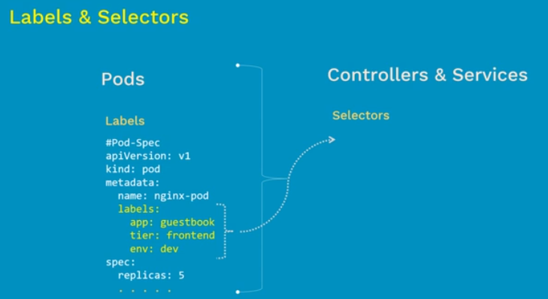

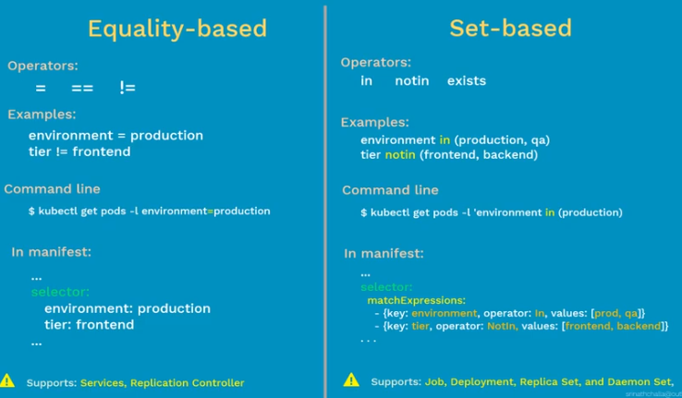

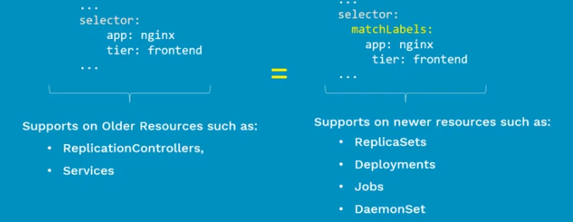

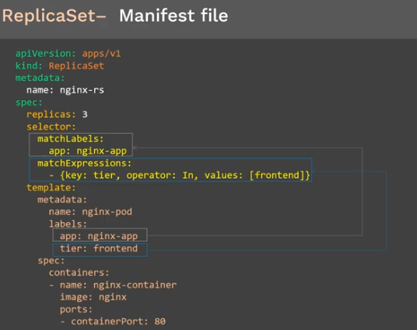

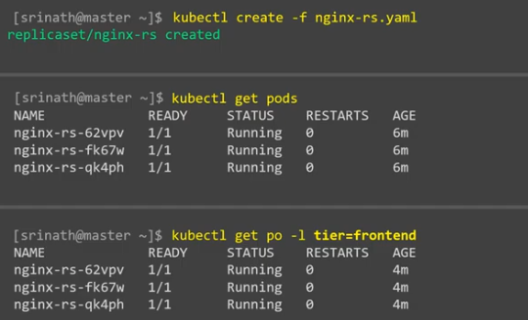

Rest all functionality remain same as RC like Node fails, scaling rs and scale down rs.

Also delete remain same.

# Deployments in Kubernetes

Deployment in K8s is controller which is responsible for updates/upgrade n rollback

No need to maintain separate manifest file for each of kind like RS, Pods. Instead we ll create only one manifest file that is deployment.

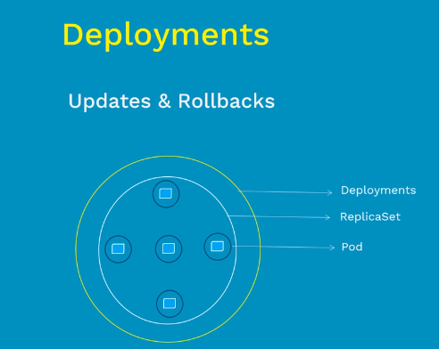

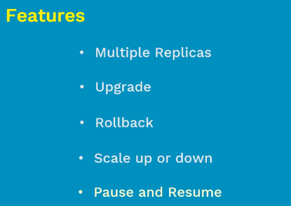

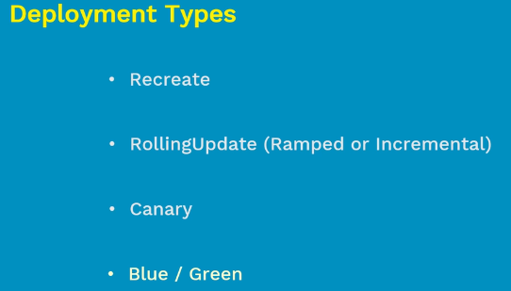

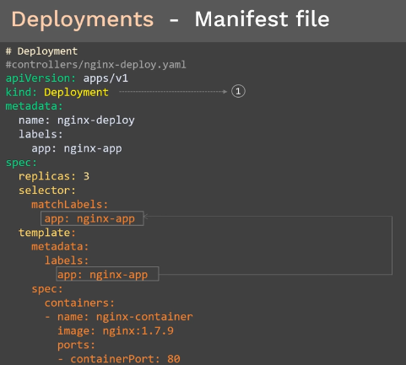

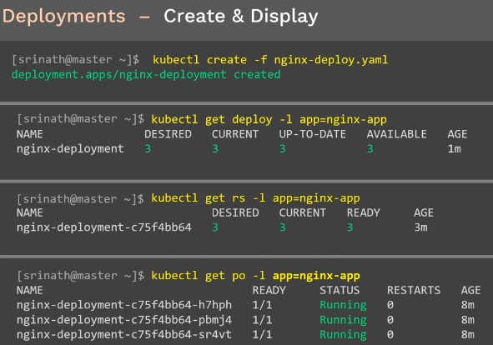

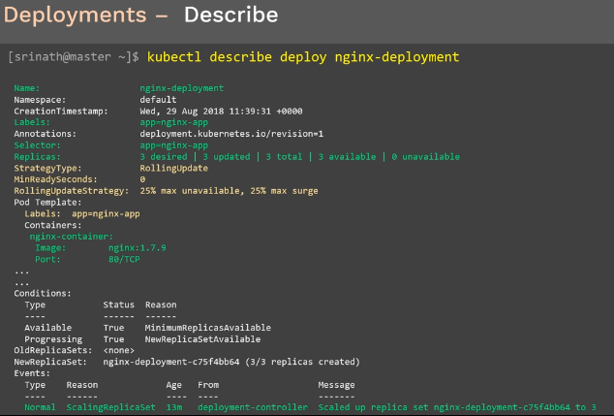

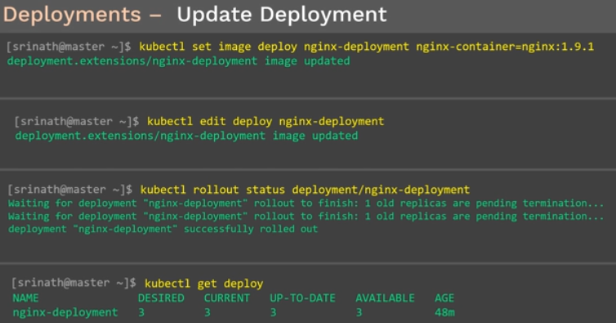

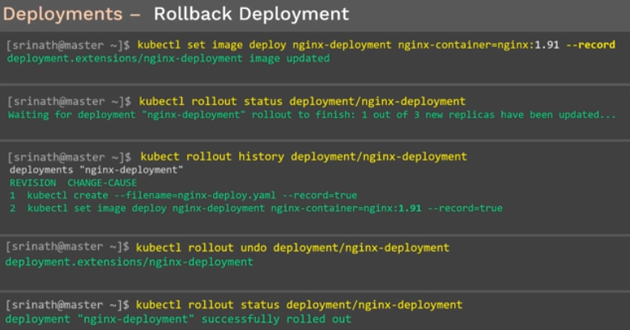

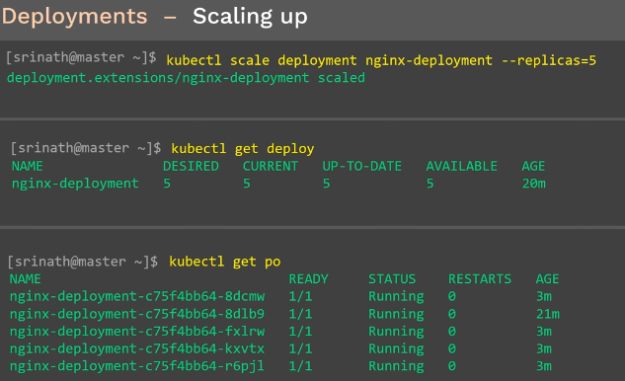

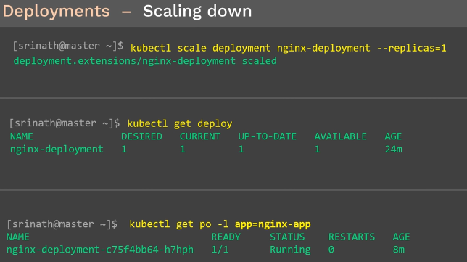

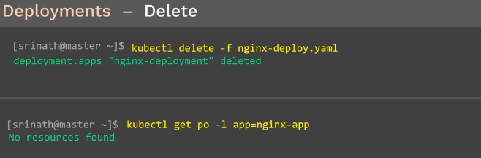

# Services in Kubernetes

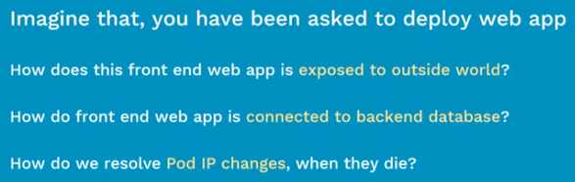

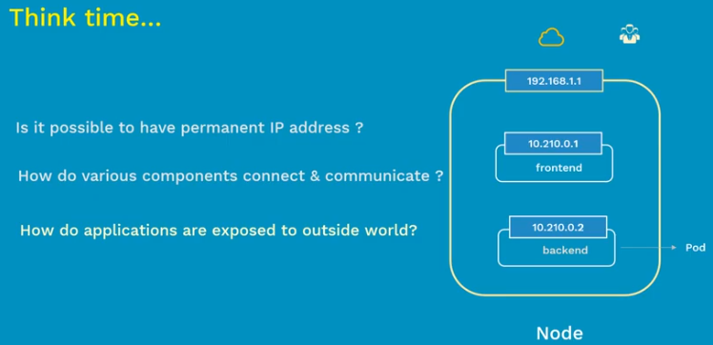

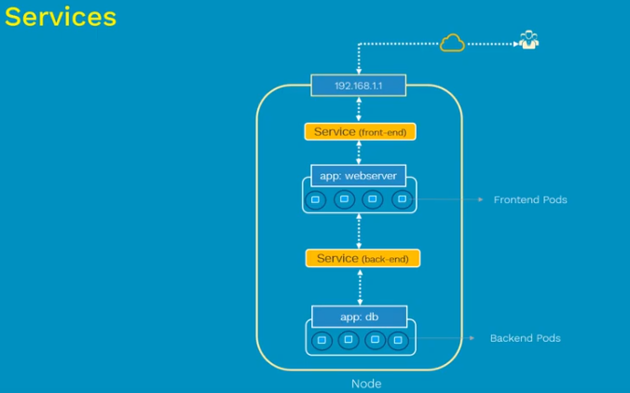

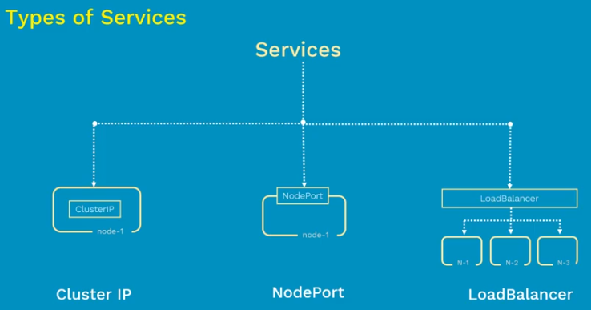

# NodePort Service in Kubernetes

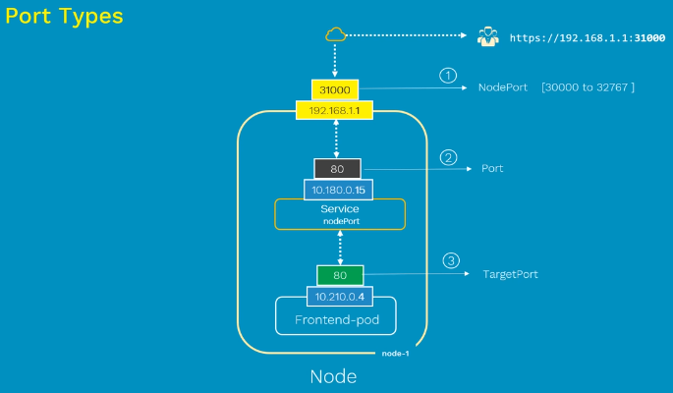

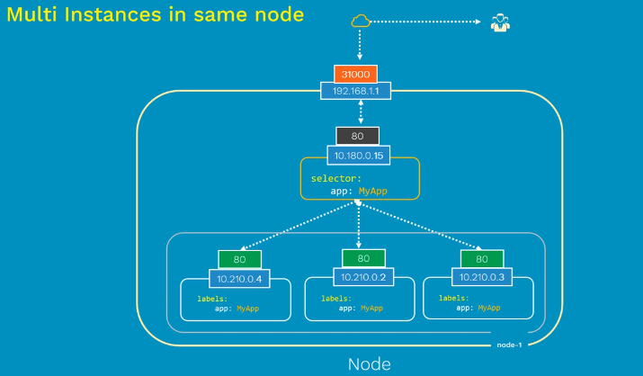

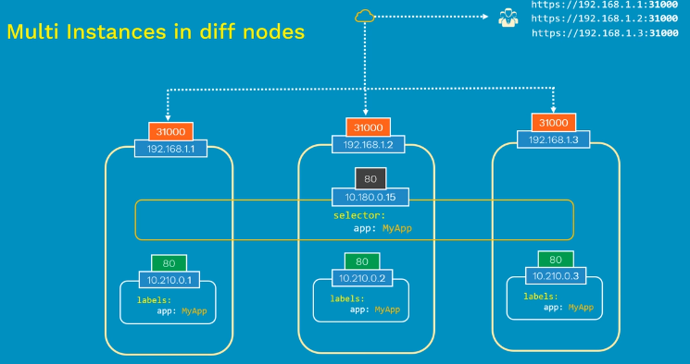

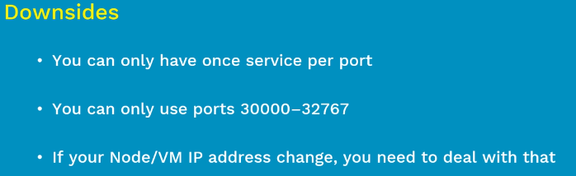

Is used for demo purpose not for production.

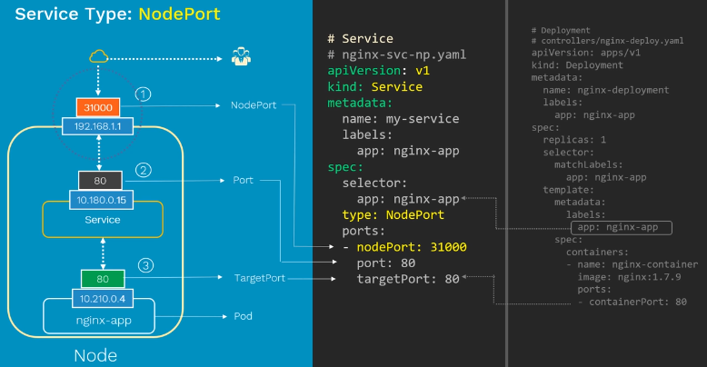

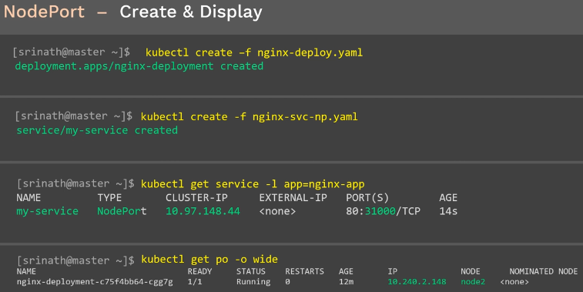

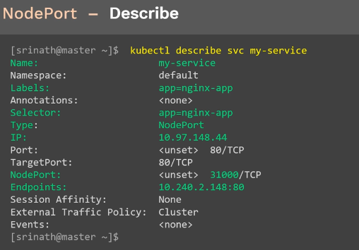

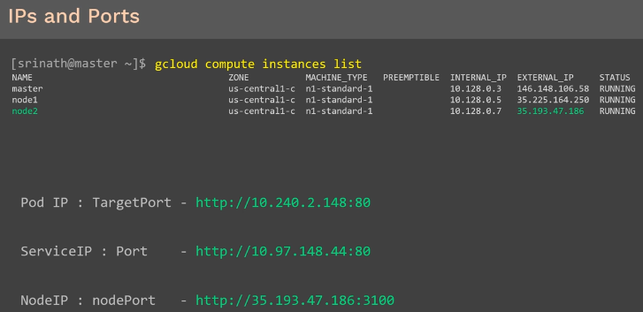

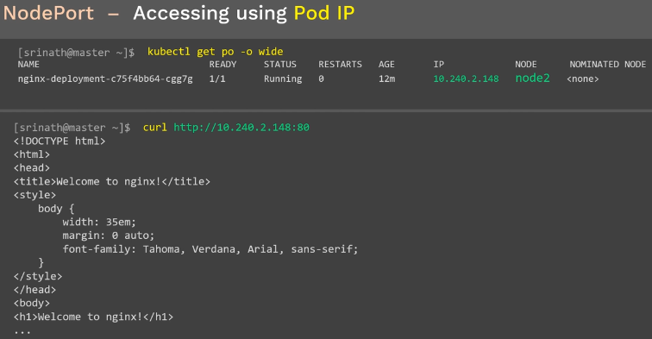

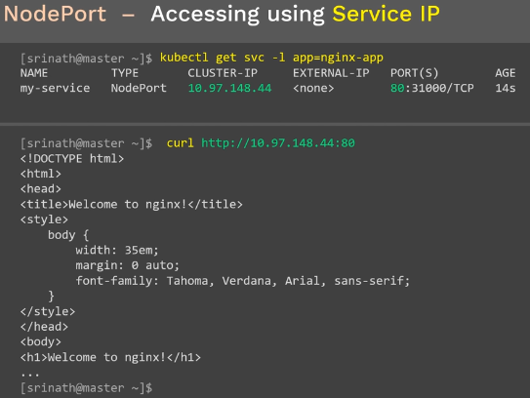

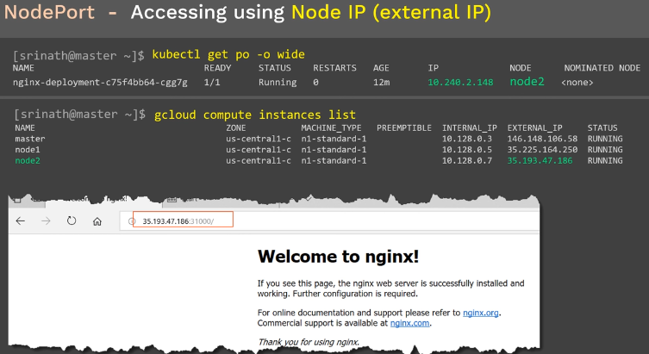

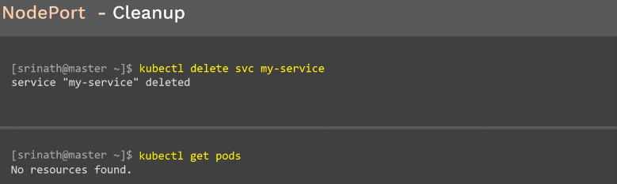

# Load Balancing Service in Kubernetes

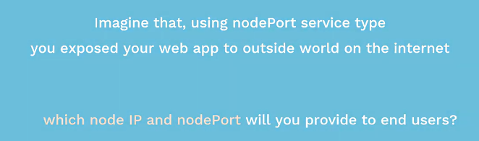

Which nodeIP will be provide to enduser? We need use load balancer

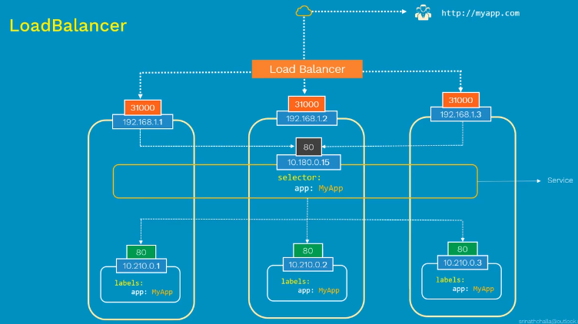

Load Balancer server are expensive.so we can use ingress

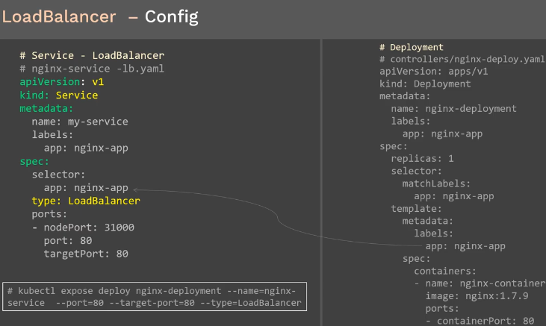

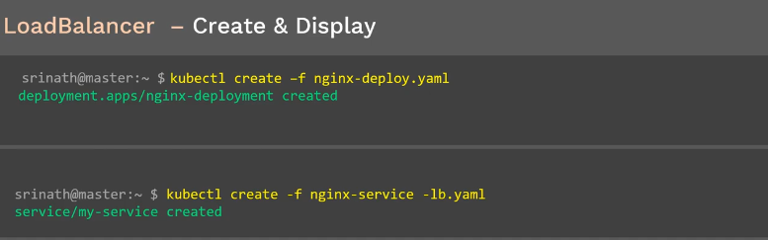

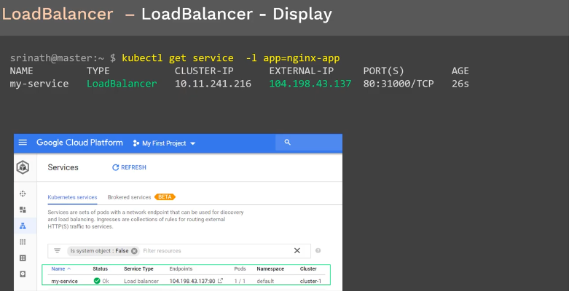

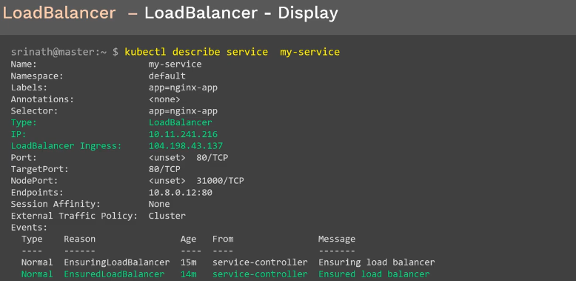

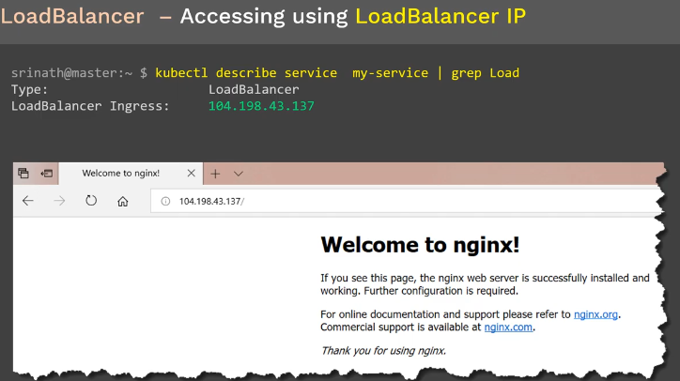

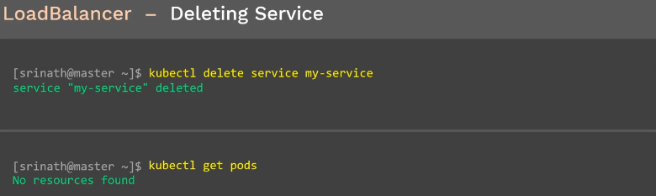

How the pods are deleting once we delete service? That is using label

# ClusterIP Service in Kubernetes

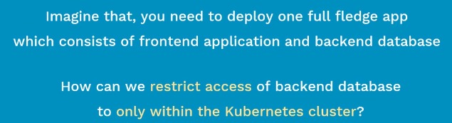

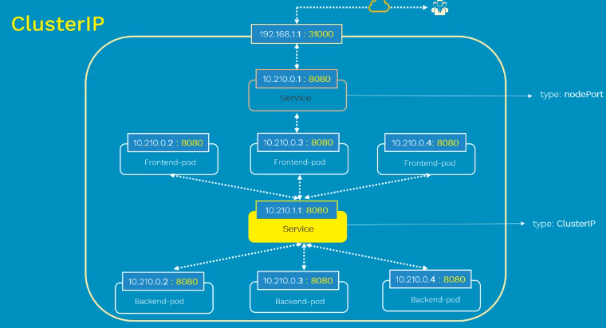

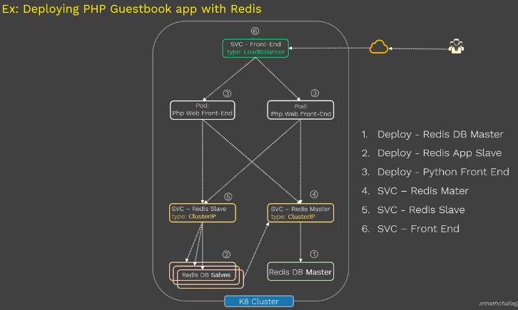

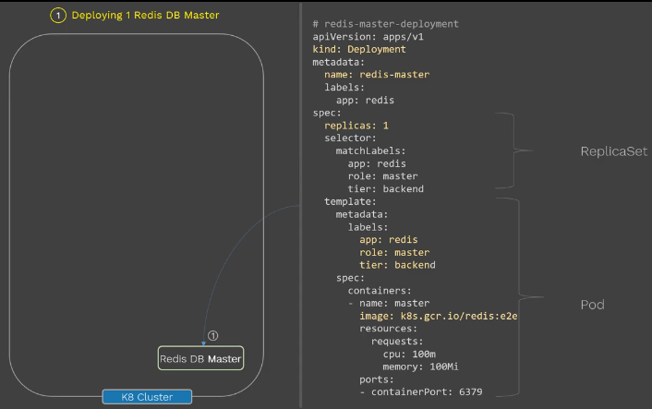

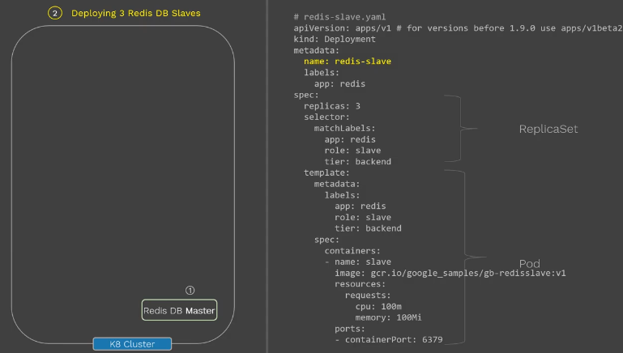

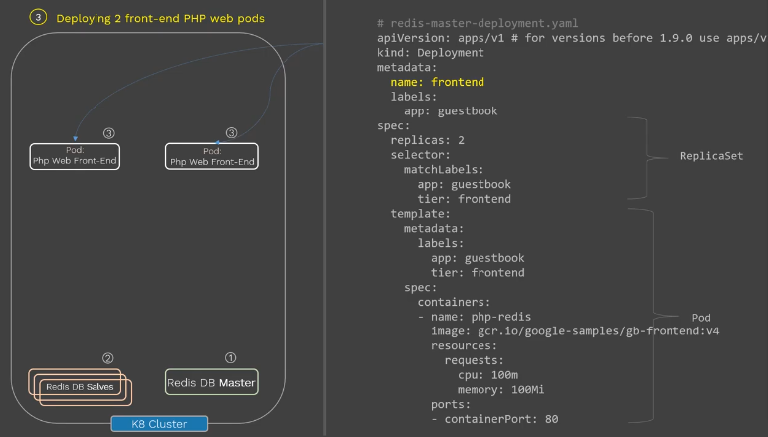

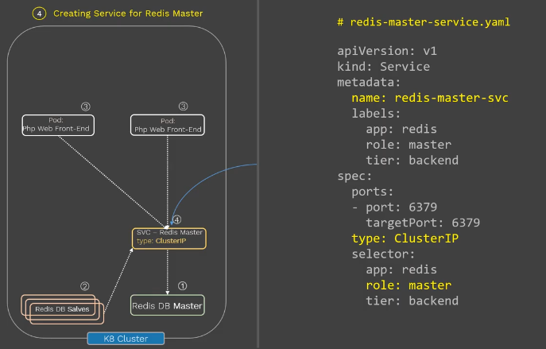

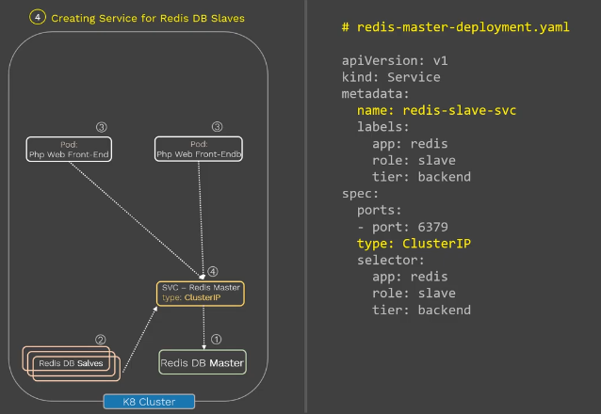

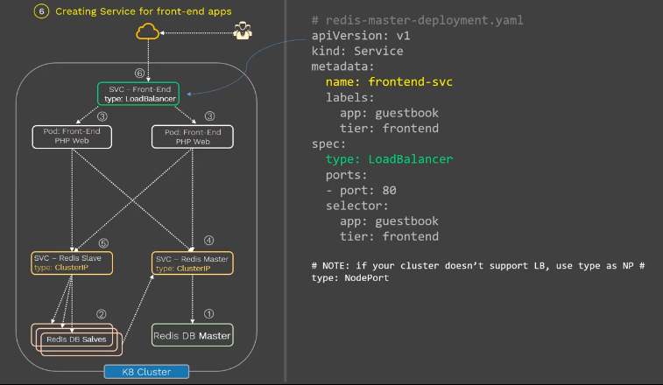

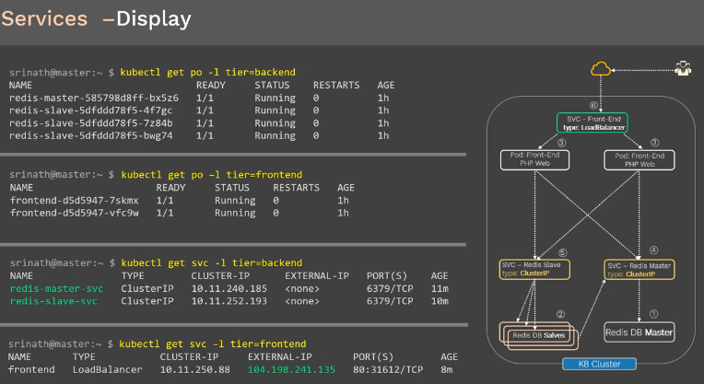

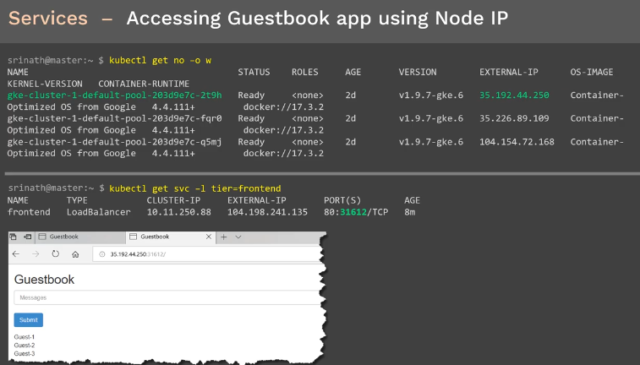

# Storage Volumes in Kubernetes

